Main

Environmental Anomaly Detection System

**UI**

The system shall have a main page with the same layout as the sample image figure 1:

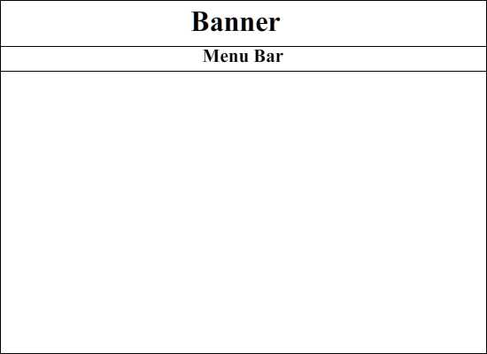

Figure 1

The system shall have a main page with the following buttons:

* A button labeled “Login”
* A button labeled “Proceed to Sensor Map”
* A button labeled “Wizard”

The system shall have a “Login” button in the menu bar align to the right end of the screen.

The system shall have a “Welcome” text in the center of the screen below the banner explaining what the system is supposed to do and who it is designed for.

The system shall have a “Wizard” button on the bottom left hand side of the screen.

The system shall have a “Proceed to Sensor Map” button on the bottom center of the screen beneath the “Welcome”.

**Stimulus**

When the “Login” button is clicked the system shall display a screen over the welcome page which will contain the login page.

When the “Wizard” button is clicked the system shall redirect to another page where the wizard guidance will be displayed.

When the “Proceed to Sensor Map” button is pressed the system shall redirect to sensor search map for the guest user.

Sensor Filter

**UI**

The system shall have a “Back to Map” button located at the upper right hand side of the screen.

The system shall have a table in the center of the screen which will have three columns:

* A column labeled “Sensor”
* A column labeled “Location”
* A column labeled “Type”.

The system shall have a table that will have a scroll bar on the right hand side of the sensor filter table.

The system shall have a table with the “Sensor” column that will display the serial number of the associated sensor.

The system shall have a table with the “Location” column that will display the longitude and latitude gps coordinates of associated sensor.

The system shall have a table with the “Type” column that will display what the associated sensor measures.

The system shall have columns on the sensor filter table that are clickable.

The system shall have rows on the sensor filter table that are clickable.

The system shall have a combo box on the right of the table that will contain the selectable options:

* An option labeled “Filter”; “Filter” shall be the default selection.
* An option labeled “Sensor”
* An option labeled “Location”
* An option labeled “Type”

The system shall have a text box beneath the combo box where the user can type text that the user would like to filter by.

**Stimulus**

When the “Back to Map” button is press the system shall redirect to the search by “map page”.

When the heading of one of the columns is clicked the system shall sort the table based on the items of the clicked column.

When a row of data on the table is clicked the system shall redirect to the “develop data properties” page passing the clicked sensor serial number.

When an item other than “filter” is selected from the combo box and text is inputted into the text box the system shall search the selected column for the typed text, displaying all sensors that meet the condition of interest.

**TRACKING**

The system shall have the following labeled buttons below the table:

* A button labeled “Delete”
* A button labeled “Edit”

he system shall have a table with a column label “Data property name” that will have the registered user specify name for property the user is tracking.

The system shall have a table with a column labeled “Author” which will contain the name of the original creator of the property.

The system shall have a table with a column labeled “Type” which will contain the type of data the sensor is measuring.

The system shall have a table with a column labeled “Date Created” which will contain the date the property was created.

The system shall have a table with a column labeled “Location” which will contain the gps coordinates of the sensor location.

The system shall have a table with a column labeled “Sensor” which will contain the serial number of the sensor being tracked

The overlays shall contain text fields containing name of data property, author, scope, and pattern

The overlay for edit shall have the text fields already filled in with the information already created

The overlay for create shall have the text fields empty

The copy command shall copy all the current existing data from a data property with the exception of the author, which will be changed according to the user logged in

The system shall allow the registered user to format a data file, which will contain all the raw information coming from the sensors

The system shall provide the registered user with drop down menus which will contain different fields from the file such as date, time, sensor, and data

The user shall be able to specify the length of each data field through a text field below the drop down menus

The user shall be able to save the file once it has been formatted

**Behavior**

The system shall allow registered users to add data properties to a personal tracking list.

The system shall allow the user to copy a data property.

The system shall allow the user to click on a data property and view data in a graph.

The system shall allow the user to search through the data property via search bar.

The system shall allow the user to click on command button.

The system shall display overlays based on the command selected.